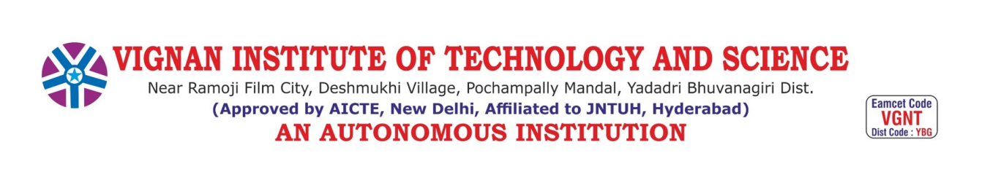

**SMART VOTING SYSTEM THROUGH**

**FACIAL RECOGNITION**

**A RTRP PROJECT REPORT**

Submitted by

**Akula Sankeerthana (Reg. No. 22891A6667)**

**Sariri Bhargavi (Reg. No. 22891A66C1)**

**Gaddam Soumya (Reg. No. 22891A6684)**

Under the guidance of

**Dr.K.RAMAKRISHNA REDDY**

Associate Professor

*in partial fulfillment of the degree of*

**BACHELOR OF TECHNOLOGY**

in

**COMPUTER SCIENCE AND ENGINEERING (AI & ML)**

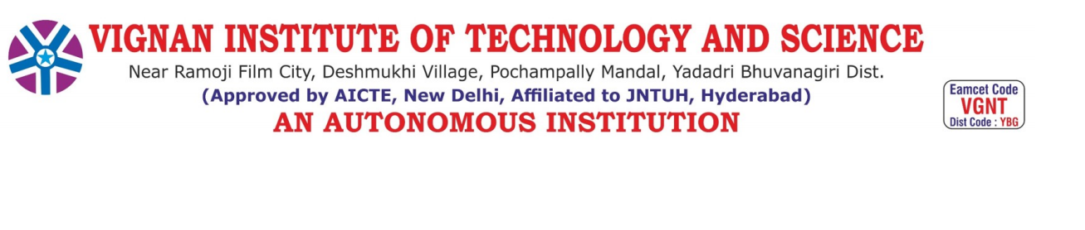

**CERTIFICATE**

This Is to certify that the project work titled “**SMART VOTING SYSTEM THROUGH FACIAL RECOGNITION ”**submitted by **A.Sankeerthana(22891A6667), S.Bhargavi(22891A66C1), G.Soumya(22891A6684),**in partial fulfillment of the requirement for the award of the degree of Bachelor of Technology in Computer Science and Engineering(AI&ML) to Vignan Institute of Technology And Science, Deshmukhi is a record of bonafide work carried out by them under my guidance and supervision.

The results embodied in this project report have not been submitted in any university for the award of any degree, and the results are achieved satisfactorily.

**DR.K.RAMAKRISHNA REDDY Dr. J. R. V. Jeny**

**Project Guide Head of the Department**

**External Examiner**

**DECLARATION**

We hereby declare that the project entitled “**SMART VOTING SYSTEM THROUGH FACE RECOGNITION ”** is bonafide workduly completed by us.It doesn’t contain any part of the project submitted by any other candidate to this or any other institute of the university. All such materials that have been obtained from other sources have been duly acknowledged.

**A.Sankeerthana**

**(Reg.No. 22891A6667)**

**S.Bhargavi**

**(Reg.No. 22891A66C1)**

**G.SOUMYA**

**(Reg.No. 22891A6684)**

**ACKNOWLEDGEMENT**

The fulfillment that accompanies the successful completion of our project, this is our moment to convey our heartfelt gratitude to all those who have played an instrumental role in our mini project’s realization. Sincere thanks are extended to **Dr. L. Rathaiah**, the esteemed Chairman of Vignan Group of Institutions.

Our expression of gratitude further extends to **Mr. Boyapati Shravan**, the

distinguished CEO of Vignan Group of Institutions, Hyderabad.

We also extend our heartfelt gratitude to **Dr. G. Durga Sukumar**, our es-teemed Principal, for generously providing us with the necessary facilities and resources that were instrumental in the successful undertaking and completion of this minor project.

Our profound gratitude goes to **Dr. J. R. V. Jeny**, Professor and Head of the Department, whose unwavering encouragement and support have been a source of inspiration throughout the course of our project. Her guidance and mentorship have played a pivotal role in shaping our project and fostering a conducive learning environment. We are deeply indebted to her for her invaluable contributions and for being a guiding light on our academic journey.

We are also very grateful to project coordinator, **DR.K.RAMAKRISHNA REDDY**, Associate Professor, for her help in solving problems during our rtrp project. Our sincere thanks to our guide,**DR.K.RAMAKRISHNA REDDY**, Assistant Professor for her guidance, constant supervision, and necessary information regarding the rtrp project, as well as her support in completing it.

Last but not least, we wish to express our gratitude and thanks to friends and beloved parents for their support and help.

**ABSTRACT**

In India, currently there are two types of voting systems in practice. They are secret Ballot paper and Electronic Voting Machines (EVM), but both of the processes have some limitations or demerits. In India online voting has not been implemented yet. The current voting system is not safe and secure too. The voters need to go to distributed places like polling booths and stand in a long queue to cast their vote, because of these reasons most of the people missed their chance of voting. The voter who is not eligible can also cast its vote by fake means which may lead to many problems. That’s why in this project we have to propose a system or way for voting which is very effective or useful in voting. In our approach we have three levels of security in the voting process. The first level is the verification of unique id number (UID), second level is the verification of election id number (EID) and third level is face recognition or face matching. The security level of our system is greatly improved by the new application method for each voter. The user authentication process of the system is improved by adding face recognition in an application which will identify whether the particular user is an authenticated user or not.

**TABLE OF CONTENTS**

**TITLE PAGE NO**

**CHAPTER - 1 INTRODUCTION 1**

1.1 Introduction 1

1.2 Existing System 3

1.3 Problem Statement 4

1.4 Proposed System 5

**CHAPTER - 2 LITERATURE REVIEW 12 CHAPTER - 3 REQUIREMENTS AND DOMAIN 15**

3.1 Requirement Specification 15

3.2 Domain Information 17

**CHAPTER - 4 SYSTEM METHODOLOGY 21**

4.1 System Architecture 21

4.2 Algorithms 30

4.3 System Design 33

**CHAPTER - 5 EXPERIMENTATION 41**

5.1 Experimentation 42

5.2 Testing 53

5.3 Results 55

5.4 Screenshots 56

**CHAPTER - 6 CONCLUSION 59**

6.1 Conclusion 59

6.2 Future Scope 60

**REFERENCES 61**

**CHAPTER 1**

**INTRODUCTION**

* 1. **INTRODUCTION**

In India, the current voting system consists of two primary methods: the secret ballot paper method, which involves extensive use of paper, and the Electronic Voting Machine (EVM) method, which has been in use since 2003. Despite these advancements, there is a pressing need for a more secure and efficient voting system. This proposal introduces an online voting system that leverages face detection and recognition technology to ensure higher security and accuracy in identifying voters, thus enhancing the overall integrity of the electoral process.

Our proposed system incorporates three levels of verification for voters, making it significantly more secure than the existing methods. The first level is the verification of the voter's Unique ID number, such as the Aadhaar number, which ensures that the individual is registered and eligible to vote. This initial step filters out any unregistered or ineligible individuals from the voting process. The second level involves verifying the voter's Election Commission ID or voter card number. This step cross-references the voter's credentials with official records, adding an additional layer of security. If this ID is validated, the voter proceeds to the third and final level of security: facial recognition.This database is a comprehensive collection of facial images of all registered voters, ensuring that the system has accurate and up-to-date information. Only if the captured image matches the stored image can the voter cast their vote.

This multi-tiered verification process addresses the shortcomings of the existing system, where security is primarily reliant on the voter card, which can be easily misused. By introducing facial recognition as the main security level, the proposed system ensures that only the rightful owner of the voter card can cast the vote. This enhancement makes the voting process more secure and trustworthy, mitigating the risks of impersonation and fraudulent voting practices. Moreover, the proposed online voting system offers additional benefits beyond security. It increases accessibility, allowing individuals who might face difficulties reaching polling stations, such as those with disabilities, elderly voters, or people living in remote areas, to participate in the democratic process from their homes.

This convenience can lead to higher voter turnout and a more representative electoral outcome. Additionally, it reduces the need for physical infrastructure and the manpower required to manage polling stations, thus lowering the overall costs associated with conducting elections.

Overall, integrating facial recognition technology into the voting system represents a substantial advancement in modernizing and democratizing electoral processes. By harnessing the power of technology, this smart voting system enhances the accuracy, efficiency, and security of the voting process, paving the way for a more inclusive and resilient democratic governance framework. As India continues to evolve and embrace digital innovations, the implementation of such a secure online voting system could serve as a model for other democracies around the world, setting new standards for electoral integrity and participation.

* 1. **EXISTING SYSTEM**

In the current voting system, the ballet machines were used in which the symbols of various political parties are displayed. When we press the button with the respective party’s (political party) symbol the voting is done. The chance of a fake person casting their vote is more in the existing system. The voting person may use the fake voting card and cast his vote,this may cause problems. In the existing system, the person has to travel long places to his constituency to cast his vote. So, the process is used for detecting the right person and also making the system to work online, which will help the voters to cast their vote from their place itself.

**Disadvantages:**

**Manual Counting:** Paper ballots require manual counting, which can be time-consuming and error-prone, potentially delaying the announcement of election results and raising concerns about accuracy. Voter Errors: Paper ballots may lead to unintentional errors by voters, such as marking the wrong candidate or improperly filling out the ballot, which can result in invalidated votes.

**Ballot Design:**Poorly designed paper ballots can confuse voters or make it difficult for them to accurately indicate their choices, leading to voter frustration and potential disenfranchisement.

**Storage and Transportation:** Paper ballots need to be securely stored and transported to polling stations, which can be logistically challenging and may increase the risk of loss, theft, or damage. Voter Accessibility: Paper ballots may not be accessible to vote.

**Security Concerns:** Electronic voting machines are susceptible to hacking, tampering, or manipulation, which can undermine the integrity of the election and erode public trust in the electoral process. Technical Failures: EVMs can experience technical glitches or malfunctions, leading to lost votes, incorrect tabulations, or other disruptions that may compromise the accuracy of the election results.

**Lack of Transparency:** Some electronic voting machines operate using proprietary software, making it difficult for independent auditors or election officials to verify the integrity of the voting process and ensure that votes are accurately recorded and counted.

**Voter Verification:** Electronic voting machines may not provide voters with a tangible paper trail or receipt to verify that their votes have been cast as intended, disputes about the accuracy of the results.

**Cost:** Electronic voting machines require significant upfront investment in hardware, software, and training, which can be prohibitively expensive for cash-strapped electoral jurisdictions, particularly in developing countries.

**1.3 PROBLEM STATEMENT**

Traditional voting systems face challenges such as fraud, inefficiency, and accessibility barriers. Implementing a smart voting system using face recognition technology aims to address these issues by providing a secure, efficient, and inclusive method for voters to cast their ballots. However, ensuring the accuracy, privacy, and integrity of voter identification through facial recognition poses significant technical and ethical challenges that must be addressed for the successful implementation and adoption of such a system.

**1.4 PROPOSED SYSTEM**

In this project first the user has to register by giving his/her details and at the time of registration the user's face is captured, After registration the user has to login by giving his/her details at the time of login three levels of security is performed.

**Level1:-**Unique id number (UID). At the time of registration the voter registration system will request for the unique id from the voter. The entered unique id is verified from the database provided by the election commission.

**Level2:-**Election commission id card number. In the second level of verification, the voter has to enter the election commission id or voter’s id number. The entered id number is verified from the database provided by the election commission.

**Level3:-**Face recognition with respective election commission id number. At this level, the Eigenface algorithm is used to verify the facial image of the voters from the database provided by the election commission.The advantages of online voting systems include increased efficiency, improved accuracy, and greater voter engagement compared to paper ballots.

**Increased Efficiency:** One of the most significant advantages of online voting systems is incredible efficiency. With traditional paper-based voting, there are a lot of steps involved, from printing ballots to counting votes by hand. You can avoid all of that with online voting. With an online system, you can send out electronic ballots to all of your voters in just a few clicks. And once the voting period is over, the system will automatically tally the results, so you don’t have to do it yourself, saving your organization a lot of time and money.

**Improved Accuracy:** Another advantage of online voting systems is that they tend to be more accurate than traditional paper-based systems. On the other hand, there’s always the potential for human error with paper ballots, whether it’s miscounting votes or mixing up ballots. But with an online voting system, the votes are tallied automatically, so there’s no chance for human error, giving you peace of mind knowing that your results are accurate. Greater Turnout and Voter Engagement: Another advantage of online voting is that it can increase voter turnout because it’s more convenient for voters to cast their ballots online than to have to go to a physical polling place.

**Eigen Face Algorithm:** The main concept of the EigenFace algorithm is to follow the appearance –based approach to face recognition. It is used to capture the variation in a collection of face images and this information is use to encode the particular images of individual faces. Then the encoded images of individual faces are compared with the collection of face images in a holistic manner.

The Eigenfaces itself form a basis set of all images used to construct the covariance matrix. The formed smaller set of basis images are used to represent the original training images which produces dimension reduction. By comparing how faces are represented by the basis set, the classification can be achieved. Face Images are projected into a feature space (“Face Space”) that best encodes the variation among known face images. The face space is defined by the “eigenfaces”, which are the eigenvectors of the set of faces.

**Working of Eigen face algorithm:**

**Steps in Face Recognition:**

**•Initialization:** Acquire the training set and calculate Eigen faces (using PCA projections) which define Eigenspace.

•When a new face is encountered, calculate its weight.

•Determine if the image is face.

•If yes, classify the weight pattern as known or unknown.

•(Learning) If the same unknown face is seen several times incorporate it into known faces. Principal Component Analysis

•Eigen face follows the Principal Component Analysis approach, in which face.

**Convolutional Neural Network:**

The term "CNN algorithm" typically refers to Convolutional Neural Networks (CNNs), which are a class of deep learning neural networks commonly used for image classification tasks. In the context of e-waste classification, CNNs can be applied to automatically categorize or classify images of electronic waste into different types or categories. Here's how CNN algorithms can be utilized in the classification of e-waste:

**Image Preprocessing:** Before feeding images into a CNN model, preprocessing steps may be applied to standardize the image sizes, adjust brightness or contrast, and normalize pixel values. This ensures consistency in input data for the neural network.

**Training Data Collection:** A dataset of labeled images of e-waste items is required for training the CNN model. These images should be categorized into specific classes (e.g., laptops, mobile phones, TVs) based on the type of electronic waste.

**Training Process:**During training, the CNN model learns to recognize patterns and features specific to different categories of e-waste. The model iteratively adjusts its parameters (weights and biases) based on a loss function that measures the difference between predicted and actual class labels.

**Validation and Tuning:** The performance of the CNN model is evaluated using a validation dataset separate from the training data. Techniques like cross-validation and hyperparameter tuning are used to optimize the model's accuracy and generalization capability.

**Deployment and Inference:**Once trained and validated, the CNN model can be deployed to classify new images of e-waste items. The model takes an input image, processes it through the learned layers, and outputs a probability distribution over the predefined classes, indicating the predicted category of e-waste.

**Post-Processing and Interpretation:**Post-processing steps may involve thresholding the model's confidence scores to make final predictions. Additionally, techniques such as class activation mapping (CAM) can be used to visualize which parts of the input image contributed most to the model's decision.

**Benefits of using CNN algorithms for e-waste classification include:**

**•Automation:** CNNs can automate the process of categorizing e-waste items based on visual characteristics, reducing the need for manual intervention.

**•Scalability:** Once trained, CNN models can efficiently process large volumes of e-waste images, making them suitable for real-world applications.

**•Accuracy:** CNNs can achieve high accuracy in classifying e-waste items when trained on diverse and representative datasets. Overall, CNN algorithms offer a powerful and effective approach to automatically classifying and categorizing e-waste based on visual content, enabling more efficient and scalable e-waste management processes.

**PURPOSE AND MOTIVATION**

A smart voting system using face recognition could have several purposes and motivations:

**Enhanced Security:** Face recognition adds an extra layer of security to the voting process by ensuring that only registered voters can cast their ballots, reducing the risk of fraudulent voting.

**Efficiency:** Automating the identification process through face recognition can streamline the voting process, reducing queues and wait times at polling stations.

**Accessibility:** It can make voting more accessible to individuals with disabilities or those who may have difficulty with traditional identification methods.

**Accuracy:** Face recognition technology can help ensure the accuracy of voter identification, reducing the chances of errors in the voting process.

**Transparency:** By providing a digital record of voters' identities, the system can enhance transparency and accountability in the electoral process.

**Prevention of Voter Fraud:** Face recognition can help prevent instances of voter fraud, such as individuals attempting to vote multiple times under different identities.

**Data Analysis:** The system can also collect data on voter demographics, which can be useful for analyzing voting trends and making informed decisions for future elections. Overall, the purpose of implementing a smart voting system using face recognition is to improve the integrity, efficiency, and accessibility of the electoral process.

**OBJECTIVES**

To accomplish the project's purpose, the following particular objectives have been established.

• Machine-learning model selection and development.

• Development of a web-based interface for Voting.

• Integration of the developed model to a web application.

• Ensuring Data Security and Privacy.

• Performance Optimization and Testing.

**Scope of the project**

The following are the boundaries that have established in the proposed system which defines scope.

• Reduce the fake votes by validating a user through face recognition.

• A User can cast their vote, only if the user details already existed in database.

• The system does not allow same voter to cast their vote for multiple times.

**Project Overview**

Voting is a method to make a collective decision or express an opinion among a group or a meeting. Voting is usually following debates, discussions, and election campaigns. During voting, the person to be elected is the candidate of an election, and the person who casts a ballot for their chosen candidate is the voter. Usually, the voter can vote in accordance with the list of candidates or vote for any other persons he/she prefers.Voting ballots must be unsigned and marked by the voters in private booths so that no one else can find out for whom voters and election authorities. The voter can submit his/her votes electronically to the election authorities from any location via e-voting. The election authorities are responsible for collecting votes from voters.

The term "CNN algorithm" typically refers to Convolutional Neural Networks (CNNs), which are a class of deep learning neural networks commonly used for image classification tasks. In the context of e-waste classification, CNNs can be applied to automatically categorize or classify images of electronic waste into different types or categories. Here's how CNN algorithms can be utilized in the classification of e-waste:

**CHAPTER 2**

**LITERATURE REVIEW**

2.1 Literature Survey

“Smart Online Voting System”, Ganesh Prabhu S Department of Electronics and Communication Engineering Sri Krishna College of Technology Coimbatore, International Conference on Advanced Computing and Computing Systems (ICASS),2021

Our country, India, is the largest democratic country in the world. So it is essential to make sure that the governing body is elected through a fair election. India has only an offline voting system which is not effective and up to the mark as it requires a large man force and it also requires more time to process and publish the results. Therefore, to be made effective, the system needs a change, which overcomes these disadvantages. The new method does not force the person's physical appearance to vote, which makes the things easier.

This paper focuses on a system where the user can vote remotely from anywhere using his/her computer or mobile phone and doesn’t require the voter to get to the polling station through two step authentication of face recognition and OTP system. This project also allows the user to vote offline as well if he/she feels that is comfortable. The face scanning system is used to record the voter's face prior to the election and is useful at the time of voting. The offline voting system is improvised with the help of RFID tags instead of voter id. This system also enables the user and the citizens to see the results anytime which can avoid situations that pave the way to vote tampering.

**“A Secure Online Voting System Using Face Recognition technology”, Nazirah Abd Hamid, Citra Devi Nair Appunair,ResearchGate,2023**

Voting is a method used by groups to collectively make decisions or express opinions, and it can take various forms. One significant advancement in voting technology is Online voting, also known as E-voting, which has transformed traditional voting processes. By incorporating biometrics, E-voting has provided a more secure approach to voting in democratic nations compared to paper-based voting, which is prone to insecurity.

Deep learning is a subset of Machine Learning that utilizes multi-layered neural networks to process and analyze vast amounts of data. It mimics the functioning of the human brain. Deep learning algorithms can learn and extract meaningful information from both structured and unstructured data. Supervised and unsupervised learning are the two primary categories of deep learning, each with its own set of algorithms. Supervised learning varies based on training data that has been labeled, whereas unsupervised learning works with raw data. In this study, the focus is on supervised deep learning, specifically the Convolutional Neural Network (CNN).

CNNs are specialized network models used for processing pixel input, particularly in image recognition tasks. They excel in computer vision applications and play a vital role in accurate object recognition, such as facial recognition. The main objective of the study is to design an online voting system that can authenticate and validate legitimate users with the integration of a face recognition technology. The next objective is to develop a face recognition online voting system using the CNN algorithm. Lastly, to test the accuracy of the online voting system

to authenticate users.

**“Investigation of E-voting system using face recognition using**

**convolutional neural networks (CNN)” ,G. Revathy, K. Bhavana Raj,**

**ResearchGate,2022**

Papers vote was earlier pre supposed to be the most cost-effective method of conducting the elections. It enclosed least expense and complexities. However, since 1998, the Commission has exaggerated the usage of the Electronic Voting Machine rather than Ballot Boxes. The Electronic Voting Machine is basically a memory recorder which records the vote casted by the voters. The vote is recorded in the form of Digital information inside the memory chip in place of recording the votes on paper ballot.

These machines are smooth facilitators of election and it helps in smooth and timely counting of votes. The Commission has taken the spearheading activity of presenting an Electronic mechanical device (EVM) for recording, tallying of votes over the length and breadth of the country in an exceedingly easy, reliable and secure method. The existing system is not efficient in recognizing the images and the proposed system is designed using CNN.

**CHAPTER 3**

**REQUIREMENTS AND DOMAIN INFORMATION**

**3.1 Requirement Specification**

**3.1.1 Hardware Requirements :**

• Operating system – Windows XP/7 Higher

• Processor – i3 &above

• Hard Disk – 500GB

• RAM – 4GB and Higher

**Software Requirements**

**•** Programming Language – Python

• IDE – PyCharm

• Tools – PIP

• Framework – Django

• Database – SQLite

**SYSTEM REQUIREMENTS**

**Python:** Python is an easy to learn, powerful programming language. Python’s elegant syntax and dynamic typing, together with its interpreted nature, make it an ideal language for scripting and rapid application development in many areas on most platforms. Python is often described as a “batteries included” language due to its comprehensive standard library.

**Tool - Visual Studio:**Visual Studio is an Integrated Development Environment (IDE) developed by Microsoft to develop GUI, console, web application, web app, mobile app, cloud, and web services, etc. With the help of this IDE, you can create managed code as well as native code. It provides Support for 36 different programming languages.

**Front End – HTML, CSS, Flask:** HTML is being widely used to format web pages with the help of different tags available in HTML language.HTML (Hypertext Markup Language) is the code that is used to structure a web page and its content. For example, content could be structured within a set of paragraphs, a list of bulleted points, or using images and data tables.

CSS is the acronym for “Cascading Style Sheet” CSS is the language for describing the presentation of Web pages, including colors, layout, and fonts. It allows one to adapt the presentation to different types of devices, such as large screens, small screens, or printers. Flask is a popular Framework for developing web applications. Flask provides you with tools, libraries and technologies that allow you to build a web application. This web application can be some web pages, a blog, a wiki or go as big as a web-based calendar application or a commercial website.

**MySQL :** MySQL, the most popular Open-Source SQL database management system, is developed, distributed, and supported by Oracle Corporation. The MySQL Web site (http://www.mysql.com/) provides the latest information about MySQL software. MySQL is database software which is used to store all database related activities regarding our project and it is easily stored and retrieved the data.

**3.2 Domain Information**

**Machine Learning**

Machine Learning (ML) is a subfield of artificial intelligence (AI) that focuses on the development of algorithms that enable computers to learn from and make decisions based on data. Unlike traditional programming, where a computer follows explicit instructions, machine learning systems improve their performance over time by identifying patterns and making data-driven decisions.

Machine Learning is undeniably one of the most influential and powerful technologies in today ‘s world. Machine learning is a tool for turning information into knowledge. In the past 50 years, there has been an explosion of data. This mass of data is useless; we analyze it and find the patterns hidden within. Machine learning techniques are used to automatically find the valuable underlying patterns within complex data that we would otherwise struggle to discover.

The hidden patterns and knowledge about a problem can be used to predict future events and perform all kinds of complex decision making. To learn the rules governing a 12phenomenon, machines have to go through a learning process**,** trying different rules and learning from how well they perform. Hence, why it‘s known as Machine Learning. A smart voting system using face recognition leverages machine learning to enhance security, accuracy, and efficiency in the electoral process. Here's a detailed explanation of how such a system works and its key components:

**Key Components:**

Face Recognition Technology:

**Face Detection:** The first step involves detecting faces in images or video streams. Machine learning models, particularly convolutional neural networks (CNNs), are trained to identify and locate faces within a given frame.

**Feature Extraction:** Once a face is detected, the system extracts unique features from the face, such as the distance between the eyes, nose shape, and other distinguishable landmarks. This is often done using deep learning techniques.

**Face Matching:** The extracted features are then compared against a database of registered voters' facial features. The system uses machine learning algorithms to match the current facial features with those in the database to verify the voter's identity.

**Voter Registration:** During registration, voters' facial images are captured and stored in a secure database.Machine learning models process these images to create a unique facial template for each voter

**Authentication and Voting:** On the voting day, voters' faces are scanned using cameras at the polling stations or through a mobile application. The system uses the stored facial templates to authenticate voters. Once authenticated, the system grants access to the voting interface, allowing the voter to cast their ballot.

**Machine Learning Techniques:**

**Convolutional Neural Networks (CNNs):**

CNNs are widely used for image recognition tasks, including face detection and recognition. These networks automatically learn to extract relevant features from raw images through layers of convolution and pooling operations.

**Deep Learning Algorithms:** Techniques like deep belief networks (DBNs) and autoencoders can be used for more sophisticated feature extraction and dimensionality reduction, improving the accuracy of face recognition.

**Advantages:**

**Increased Security**: Facial recognition can reduce the risk of voter fraud by ensuring that each vote is cast by the correct, registered voter, preventing impersonation and multiple voting.

**Convenience**: Voters do not need to remember or carry identification documents. This can streamline the voting process, making it quicker and more efficient.

**Accessibility**: Facial recognition can be beneficial for individuals with disabilities or those who might have difficulty handling traditional identification methods.

**Efficiency**: Automating voter verification can reduce the need for manual checks by election officials, speeding up the voting process and reducing queues.

**Accuracy**: Advanced facial recognition systems can offer high accuracy in voter identification, minimizing human error.

**Auditability**: Digital records created during the facial recognition process can aid in audits and recounts, enhancing the integrity of the election process.

**Remote Voting**: Facial recognition can facilitate secure remote voting options, such as through smartphones or computers, making it easier for those who cannot physically visit polling stations.

**Scalability**: Facial recognition systems can be scaled to handle large numbers of voters efficiently, accommodating high voter turnout without significant delays.

**Fraud Detection**: Facial recognition systems can be integrated with other databases to detect and flag suspicious activities, enhancing overall election security.

**Reduction of Voter Intimidation:**Facial recognition can help reduce instances of voter intimidation or coercion by ensuring the privacy and security of voter identities.Encourages voter participation and ensures that voters feel safe and protected.

**Real-time Identification:** Provides instant identification and verification of voters as they approach polling stations or access remote voting platforms.Enables immediate decision-making processes and reduces waiting times for voters.

**Integration with Voter Registration Systems:**Easily integrates with existing voter registration databases and systems.Ensures that only registered voters can participate, maintaining the integrity of voter rolls.

**CHAPTER-4**

**SYSTEM METHODOLOGY**

**4.1 System Architecture**

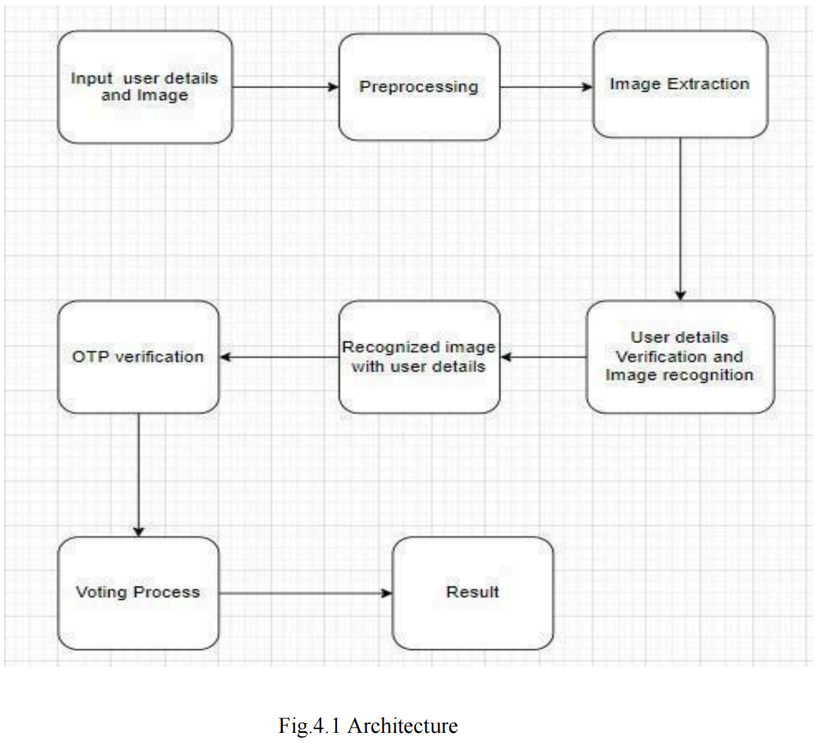

The first step in smart voting system is registration. Voters begin by providing their personal details, such as their name, UID, EID number, contact number. During this process, a photo of the voter’s face is captured using a camera. This image is crucial for identifying the voter in the future.

Next, the captured face image undergoes preprocessing to enhance its quality. This involves adjusting factors like brightness and contrast, as well as removing any noise to ensure the face features are clear. The image is also normalized, meaning it is resized and adjusted to a standard format to maintain consistency. This can be done by using Convolutional Neural Network. After preprocessing, the system performs image extraction. Specific features of the face, such as the distance between the eyes and the shape of the nose, are extracted from the image using Eigen Face Algorithm.

These unique facial characteristics are used to create a template, which is a unique code or pattern representing the face. This template is what the system uses to recognize and match faces in the future. With the user details and face template stored in a secure database, the system is ready for voter authentication. When a voter arrives to vote, their live face is scanned and the system compares this live face template with the stored templates in the database to find a match. Simultaneously, the system verifies the user details. If a match is found and the details are correct, the voter’s identity is verified.

Once the face is recognized and the user details are verified, the system links the recognized face with the user details. To add an extra layer of security, an OTP (One-Time Password) is generated and sent to the voter’s registered mobile number or email. The voter must then enter this OTP to confirm their identity. This step ensures that even if someone tries to spoof the face recognition system, they would still need access to the voter’s phone or email. After successfully verifying the OTP, the voter is granted access to the voting interface.

The voter can then select their preferred candidates or options on a secure electronic voting interface. Once they have made their selections, the vote is submitted and securely logged in the voting system’s database. After the voting period ends, the system counts all the votes. This counting process is automated to ensure accuracy. The final results are then generated based on the counted votes. These results are securely compiled and announced, ensuring the integrity and transparency of the election process.

**4.2 ALGORITHMS**

The main concept of EigenFace algorithm is to follow the appearance –based approach to face recognition. It is used to capture the variation in a collection of face images and this information is use to encode the particular images of individual faces. Then the encoded images of individual faces are compared with the collection of face images in a holistic manner.

**Appearance-Based Approach:**Utilizes the overall appearance of faces rather than specific features.Represents each face as a weighted sum of principal components (Eigenfaces).

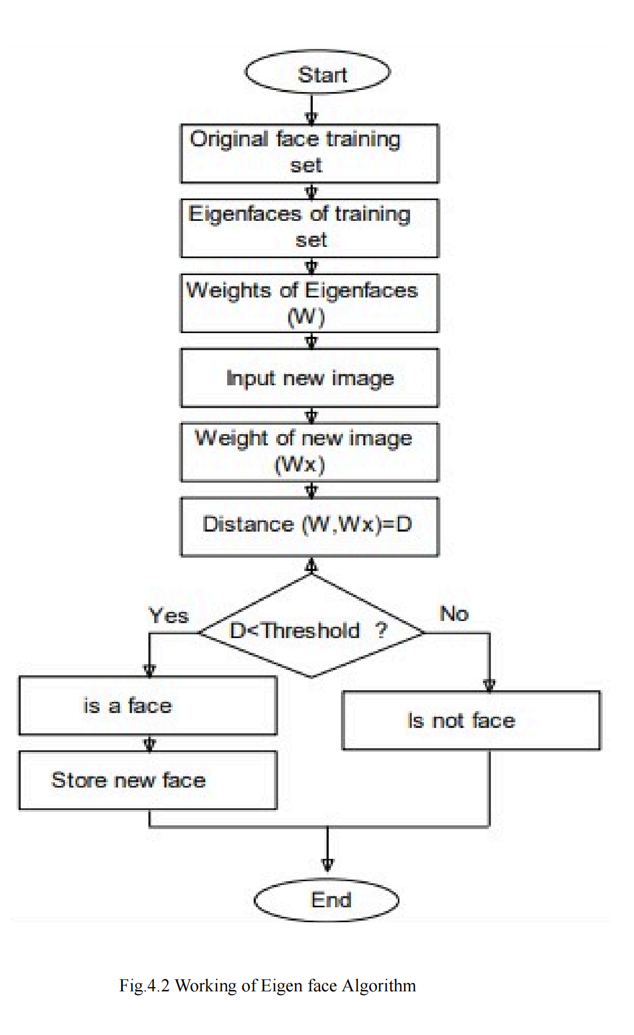

**WORKING FLOW OF THE SYSTEM**

Steps of Working Flow: -

i) Every New User in India is first registered for Voting. So, our first step is registration

ii) At that time of Registration System Capture, the Face of the user by using Web Camera and Store the Face sample in the Server Database for Security Purpose.

iii) At the time of election, we will use three levels of security. First one is unique id verification second one is voter id verification third one is face recognition.

iv) System will be checking whatever unique id and voter id entered by the voter is correct or not.

v) If a unique id or voter id is correct then the system will take an image of the voter and compare it with the respective image of the database or server.

vi) If the image in the database is matching with the captured image of the voter, then he/she is allowed to cast his vote.

vii) On the voting page all the parties in the election symbols /buttons will be there. Voter can cast his /her vote in the election.

viii) As soon as the voter will give a vote the id of voter logout automatically so we can say that a voter can give only one vote.

ix) On counting form only election commission authorized users can login with the secure id and password if both id and password is correct then voting process will be continuing.

The images below depict the raw data collected from these eleven subjects.

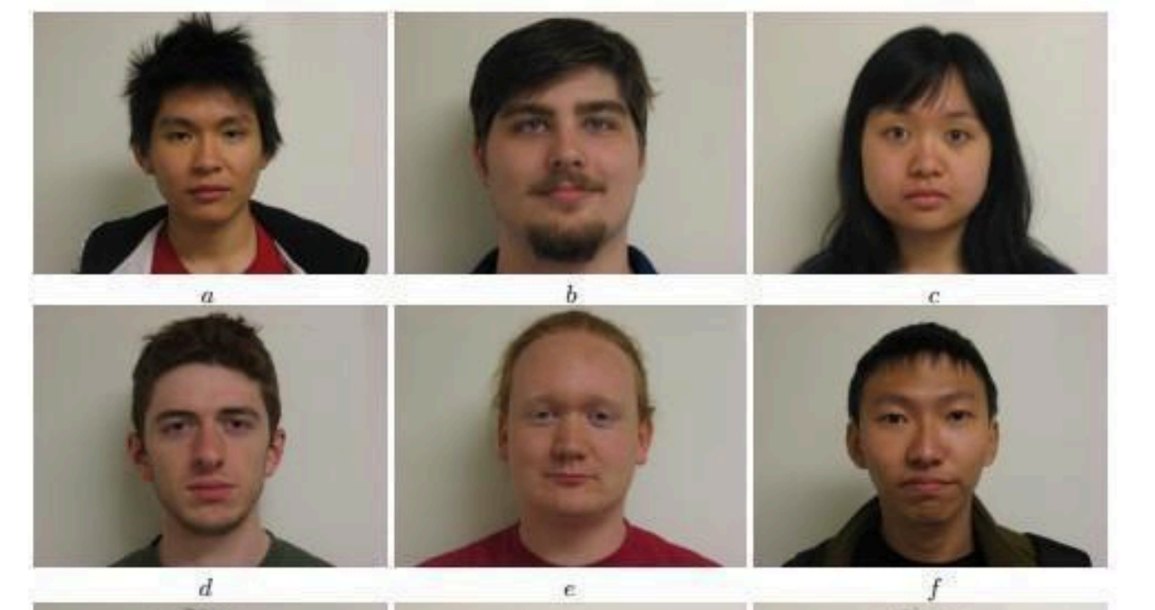

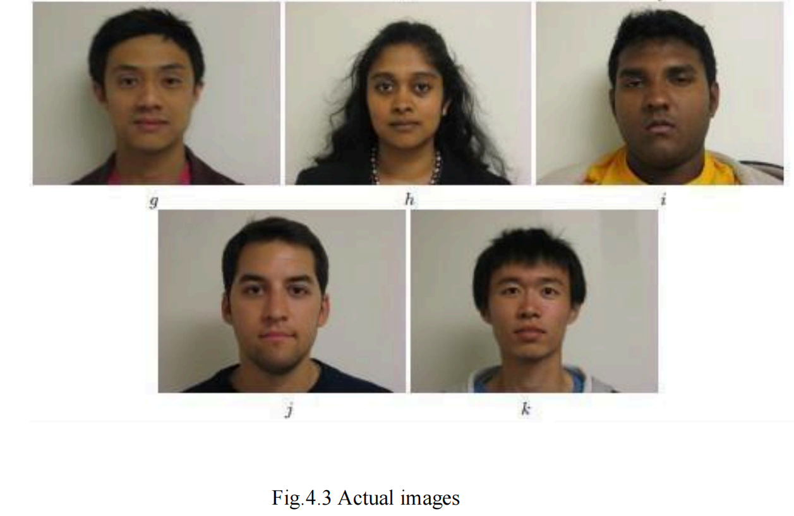

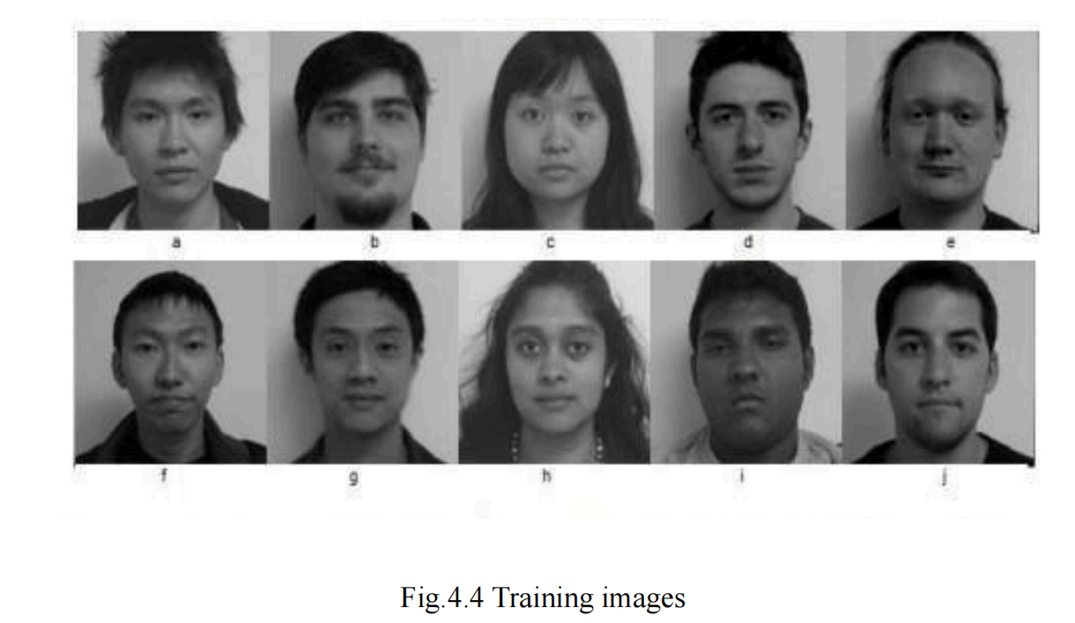

The average face is computed by taking the mean value of each pixel. Recall that we wish to manipulate the difference images (i.e. each face minus the average face). The average face of this training set was calculated and is shown below (original scale)

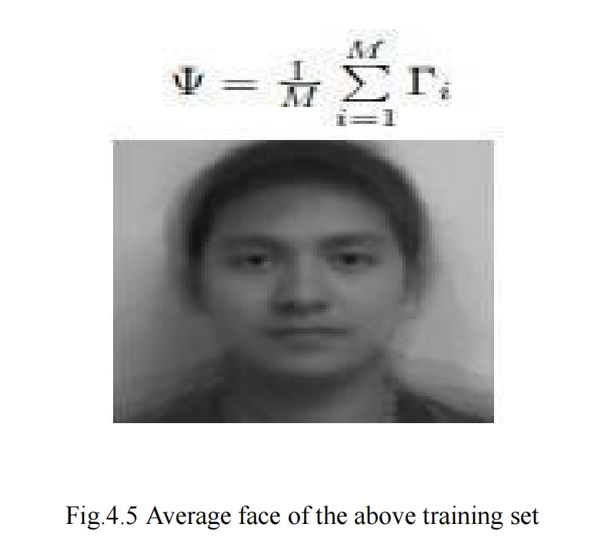

Now we compute each face minus the mean (each one of these faces will be ’reconstructed’ with a linear combination of the computed Eigenfaces). The subtracted images are shown below:

A = [Φ1, Φ2, . . . , ΦM]16384×10

The average face is computed by taking the mean value of each pixel. Recall that we wish to manipulate the difference images (i.e. each face minus the average face). The average face of this training set was calculated and is shown below (original scale)

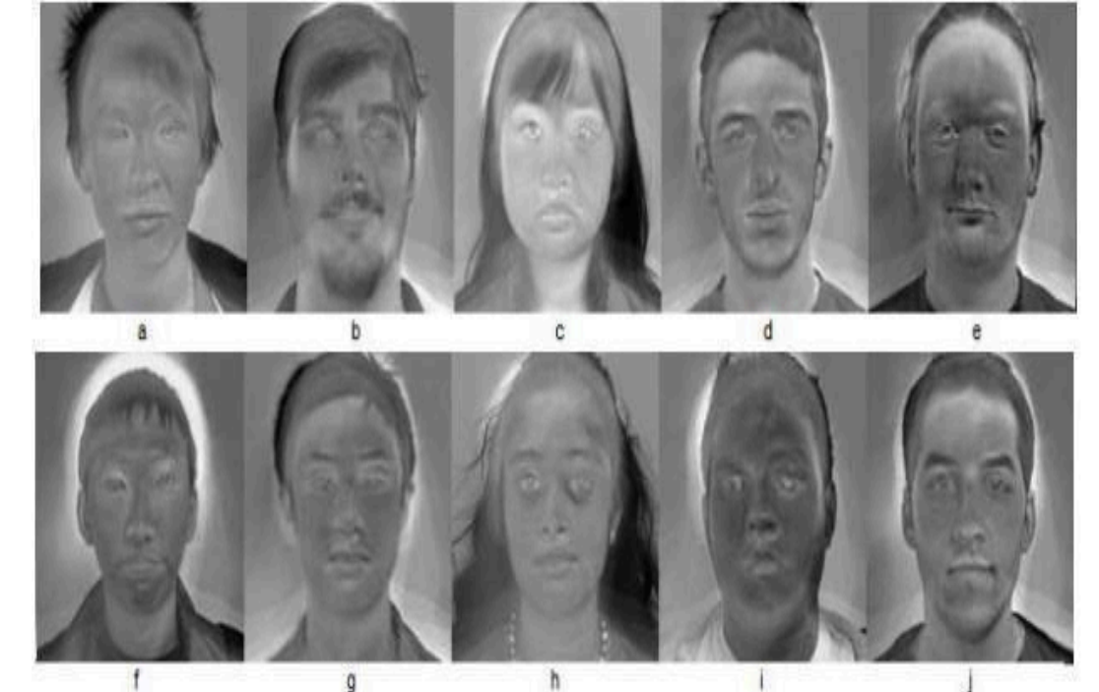

The figures below show first the frame normalized images of t1 and t2, (i.e. 128 × 128 images with facial features in relatively the same location as the training images):

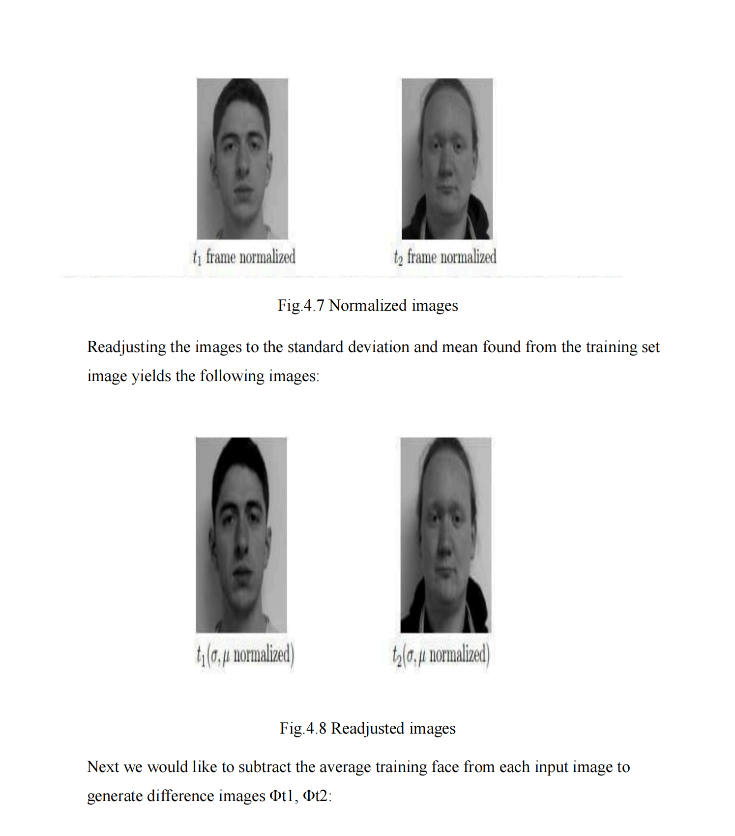

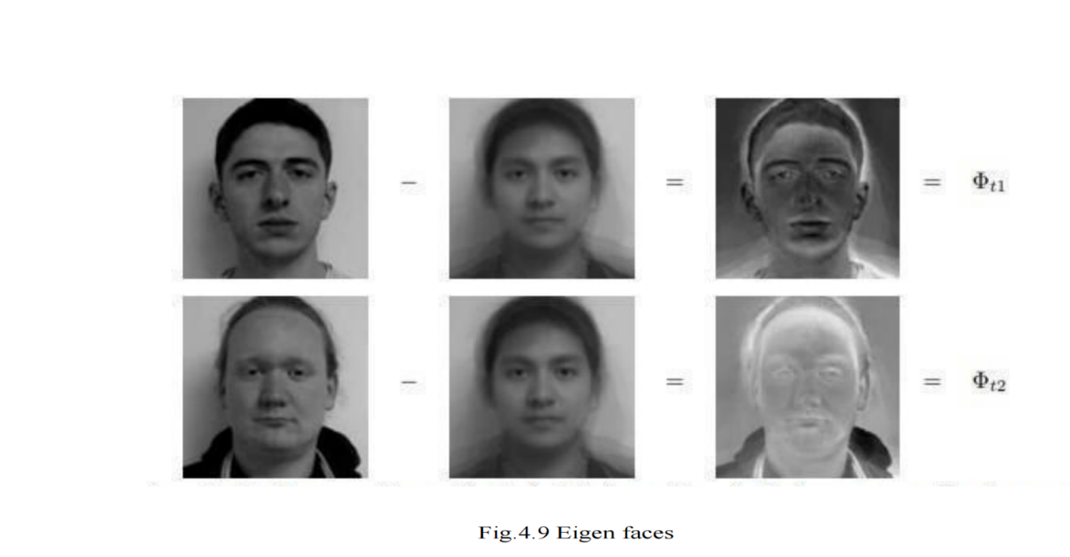

**4.2 Convolutional Neural Network:**

A standard convolutional neural network will comprise a few basic layers that could be repeated n-times in the network depending upon the subject to be predicted. The basic layers include a convolutional layer, which has a filter that will be moved across the input image. Usually, the image will be larger when compared to the filter used to slide upon it. Starting from the top of the image until the last part of it, the filter slides in a horizontal and vertical pattern, calculating the convolutional layer values by using the dot product method. These derived convolutional layer values are then passed to the next layer, which is the pooling layer.

This typically reduces the size of the values passed from the previous layer, which is actually the feature extracted from the image fed. This is also attained using a pooling filter, which slides across the previous output. Depending upon the subject that is predicted, the convolutional layer and pooling layers are iterated one after the other to produce the desired output. After the feature is extracted, it passes through a series of condensation and pooling layers, after which it is flattened out. This output is passed to the fully connected layer, where the prediction is done, and then finally at the output layer, the required prediction can be seen. In this case, the key 24points extracted from the image can be obtained at the output. The common structure of a CNN model can be seen from fig.

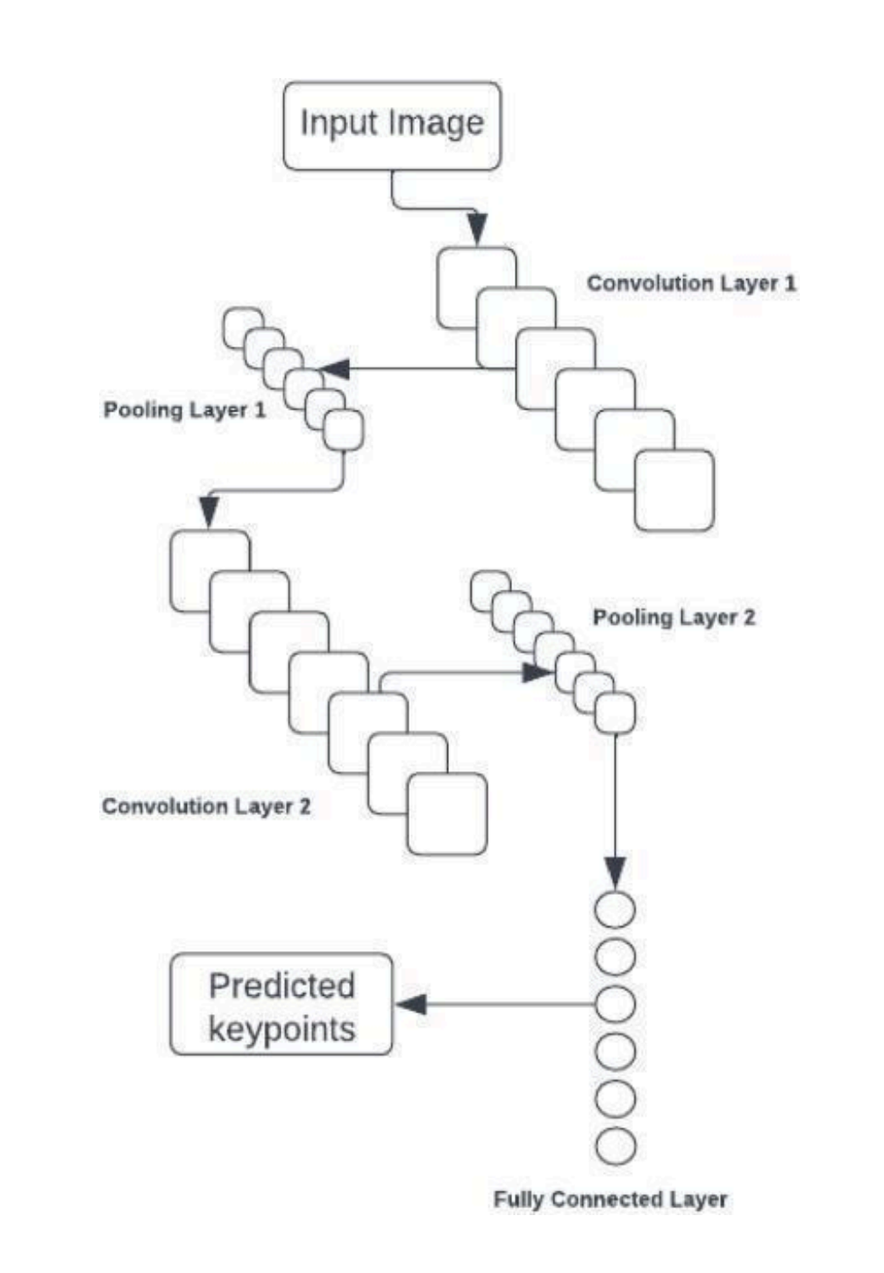

Fig.4.10 Structure of CNN

The image goes through additional preparation in the proposed CNN architecture that is not done during the preprocessing stage..The RGB-formatted input image is changed to grayscale so that the color space is changed from [0,255] to [0,1]. To ensure the consistency of the original data, which has a size of 224*224 pixels, the 25converted grayscale image is further shrunk to a standard pixel size ..

The image is fed to the convolution model once these formatting steps are complete. The architecture of the CNN model utilized for key point extraction is shown in fig

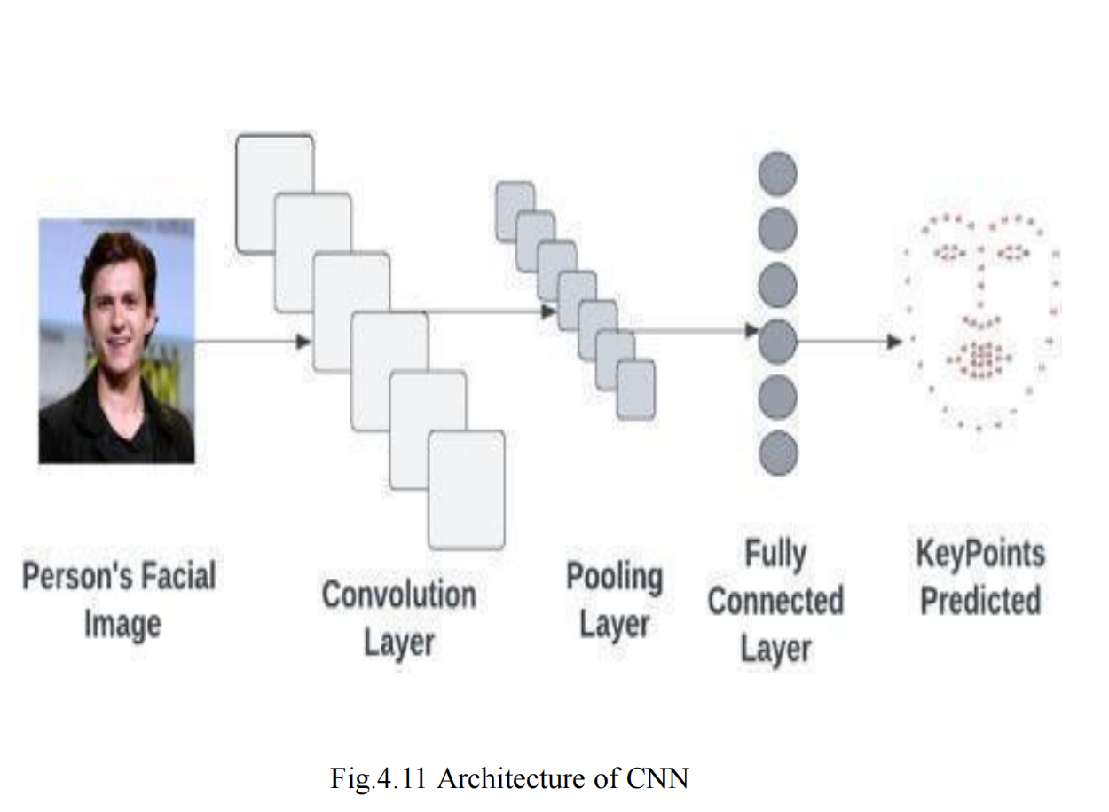

**4.3 System Design**

A flowchart is simply a graphical representation of steps. It shows steps in sequential order and is widely used in presenting the flow of algorithms, workflow or processes. Typically, a flowchart shows the steps as boxes of various kinds, and their order by connecting them with arrows.

It originated from computer science as a tool for representing algorithms and programming logic but had extended to use in all other kinds of processes.Nowadays, flowcharts play an extremely important role in displaying information and assisting reasoning. They help us visualize complex processes, or make explicit the structure of problems and tasks. A flowchart can also be used to define a process or project to be implemented.

In software development, flowcharts are invaluable for mapping out algorithms and programming logic. They enable programmers to break down complex tasks into manageable steps, ensuring systematic implementation and easier debugging. For example, in algorithm design, flowcharts help visualize the sequence of operations, conditions, and loops necessary to achieve a specific outcome.

Beyond programming, flowcharts find extensive use in project management to define workflows, allocate resources, and identify critical paths. Project managers utilize flowcharts to outline project timelines, dependencies, and milestones, facilitating effective planning and execution. This visual representation enhances team collaboration by ensuring everyone understands their roles and the project's progression.

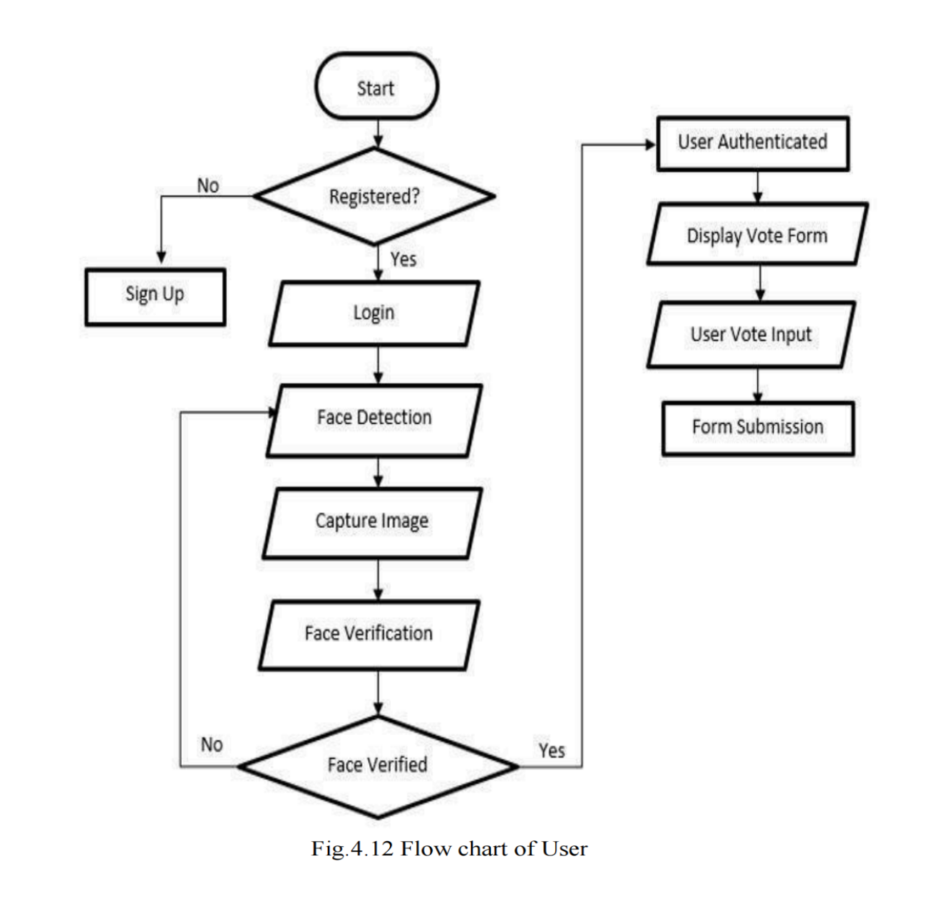

● The user has to register and at the time of registration the user has to enter the details like his/her name, UID. EID, contact number then it captures face and these details will be stored in the database.

● After the registration we have to login through our corresponding details like his/her name, UID, EID then face is detected and captured. Then After face capturing the details and the face is verified.

● If the face and details are matched then it will generate OTP after the OTP verification voting form is displayed.

● Then the voter can cast their votes.

**4.3.2 UML Diagrams**

**Use Case Diagram:**

A use case diagram in the Unified Modelling Language (UML) is a type of behavioral diagram defined by and created from a Use-case analysis. Its purpose is to present a graphical overview of the functionality provided by a system in terms of actors, their goals (represented as use cases), and any dependencies between those use cases. The main purpose of a use case diagram is to show what system functions are performed for which actor. Roles of the actors in the system can be depicted. fig 4.13 shows the use case diagram for user and admin.

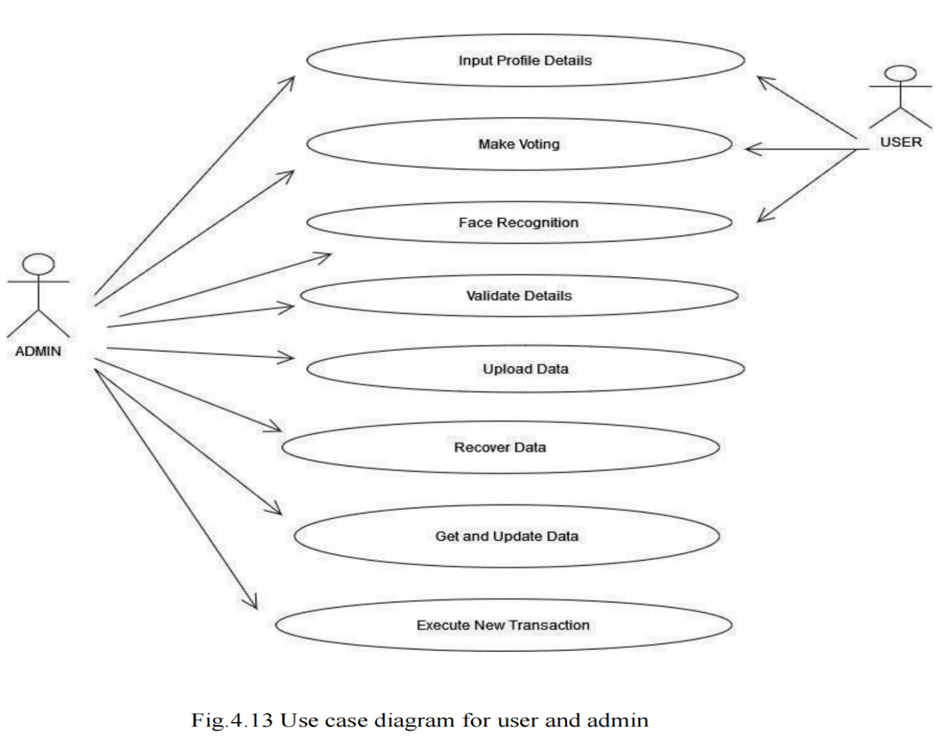

• The user actor can perform actions such as register as a voter, login as a voter and cast his/her vote.

• The admin actor can perform actions such as login, verifying registered voters, adding and eliminating candidates and view election results.

**Class Diagram :**

A class diagram in the Unified Modelling Language (UML) is a type of static structure diagram that describes the structure of a system by showing the system's classes, their attributes, operations (or methods), and the relationships among the classes. It explains which class contains information. fig 4.14 shows the class diagram for admin and user.There are four main classes: Admin, Validator, User, and Analysis.

It originated from computer science as a tool for representing algorithms and programming logic but had extended to use in all other kinds of processes.Nowadays, flowcharts play an extremely important role in displaying information and assisting reasoning. They help us visualize complex processes, or make explicit the structure of problems and tasks. A flowchart can also be used to define a process or project to be implemented.

• The Admin class represents the admin user and attributes like UID and name. It has methods to perform like generating profile, update profile. delete profile.

• The User class represents the regular user and attributes like name and OTP. It has methods to perform actions such as login, validate OTP, vote and logout.

• Validator confirms user identities with face recognition.

• Analysis analyzes election results.

• Each class plays a distinct role, contributing to a secure and effective voting process through face recognition technology.

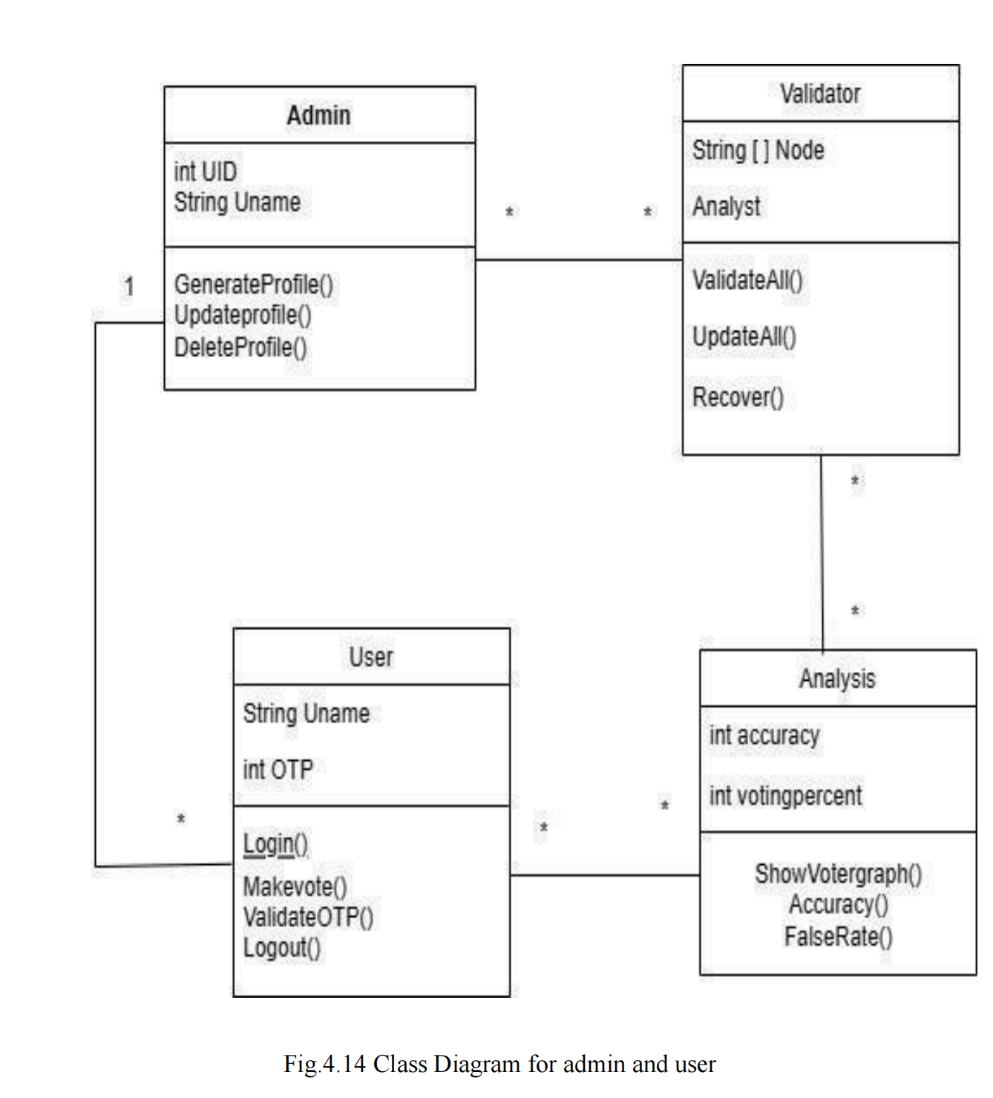

**Sequence Diagram :**

A sequence diagram in Unified Modelling Language (UML) is a kind of interaction diagram that shows how processes operate with one another and in what order. It is a construct of a Message Sequence Chart. Sequence diagrams are sometimes called event diagrams, event scenarios, and timing diagrams. fig 4.15 shows the sequence diagram for admin and user.

• In the sequence diagram of the smart voting system with face recognition, users initiate the registration process by providing personal details and facial features, which are then securely stored in the server's database. When voting, users select their choices and undergo facial recognition for identity verification before their votes are recorded.

•Meanwhile, administrators access the system to monitor user activity and system performance in real-time, ensuring the integrity and efficiency of the voting process. This sequence ensures a seamless and secure voting experience, with facial recognition adding an extra layer of authentication to prevent fraud and maintain transparency.

• The Admin class represents the admin user and attributes like UID and name. It has methods to perform like generating profile, update profile. delete profile.

• The User class represents the regular user and attributes like name and OTP. It has methods to perform actions such as login, validate OTP, vote and logout.

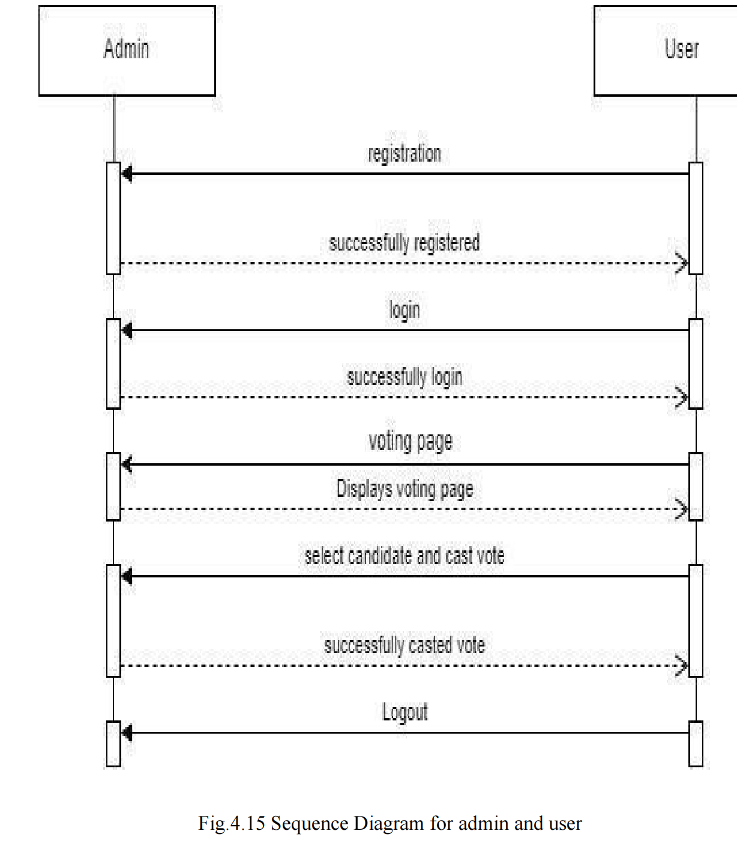

**COLLABORATION DIAGRAM**:

In collaboration diagram the method call sequence is indicated by some numbering technique as shown below. The number indicates how the methods are called one after another. We have taken the same order management system to describe the collaboration diagram. The method calls are similar to that of a sequence diagram. But the difference is that the sequence diagram does not describe the object organization whereas the

collaboration diagram shows the object organization.fig 4.16 shows the interaction between user and admin.

**User Interaction:**

**Register:**

• Users register by providing necessary details.

• Admin verifies and approves the registration.

**Login:**

• Users authenticate themselves through the login process.

• Admin grants access upon successful authentication.

**Upload Images:**

• Users upload facial images for verification.

• Admin reviews and verifies the uploaded images.

**Vote:**

• Users cast their votes in the system.

• Admin monitors the voting process for integrity.

**Logout:**

• Users log out of the system to end the session.

• Admin session management ensures security and control.

**Admin Interaction:**

**Login:**

• Admin logs into the system using credentials.

• User authentication grants access to admin functionalities.

**Takes Images:**

• Admin initiates the process for users to upload facial images.

• Users provide facial images for verification.

**Train Model:**

• Admin triggers the training of the facial recognition model using the uploaded images.

• System processes the images to improve recognition accuracy.

**Result:**

• Admin provides voting results or updates to users.

• Users receive information on the outcome of the voting process.

**Logout:**

• Admin ends the session by logging out of the system.

• Users are informed that the admin session has ended.

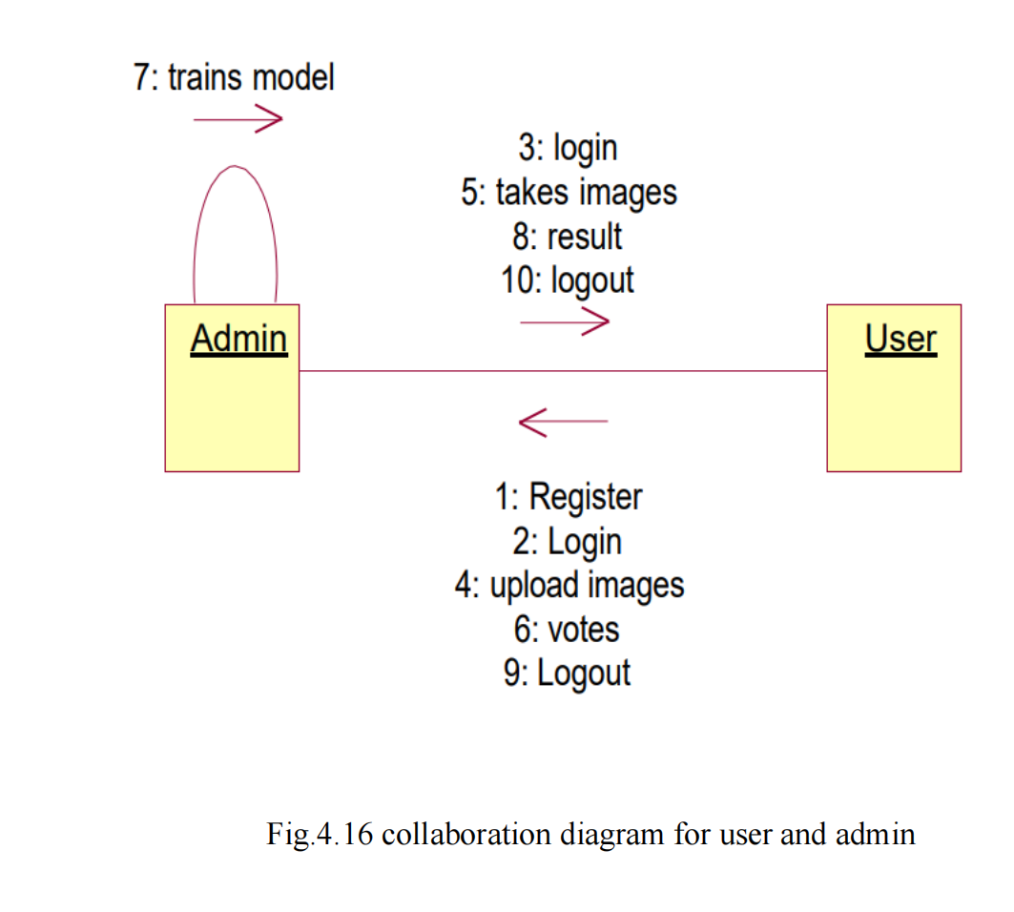

**CHAPTER 5**

**EXPERIMENTATION & ANALYSIS**

**5.1 Experimentation**

**ADD_FACES.PY:**

import cv2

import pickle

import numpy as np

import os

if not os.path.exists('data/'):

os.makedirs('data/')

video = cv2.VideoCapture(0)

facedetect=cv2.CascadeClassifier(cv2.data.haarcascades+'haarcascade_frontalface_default.xml')

faces_data = []

i = 0

name = input("Enter your voter id number: ") # Assuming input for name or identifier

framesTotal = 51

captureAfterFrame = 2

while True:

ret, frame = video.read()

gray = cv2.cvtColor(frame, cv2.COLOR_BGR2GRAY)

faces = facedetect.detectMultiScale(gray, 1.3, 5)

for (x, y, w, h) in faces:

crop_img = frame[y:y+h, x:x+w]

resized_img = cv2.resize(crop_img, (50, 50))

if len(faces_data) < framesTotal and i % captureAfterFrame == 0:

faces_data.append(resized_img.flatten())

# Flattening before appending

i += 1

cv2.putText(frame,str(len(faces_data)),(50,50), cv2.FONT_HERSHEY_COMPLEX, 1, (50, 50, 255), 1)

cv2.rectangle(frame, (x, y), (x+w, y+h), (50, 50, 255), 1)

cv2.imshow('frame', frame)

k = cv2.waitKey(1)

if k == ord('q') or len(faces_data) >= framesTotal:

break

video.release()

cv2.destroyAllWindows()

# Convert faces_data to numpy array and reshape

faces_data = np.asarray(faces_data)

faces_data = faces_data.reshape((len(faces_data), -1))

# Save or update names.pkl and faces_data.pkl

if 'names.pkl' not in os.listdir('data/'):

names = [name] * len(faces_data)

with open('data/names.pkl', 'wb') as f:

pickle.dump(names, f)

else:

with open('data/names.pkl', 'rb') as f:

names = pickle.load(f)

names += [name] * len(faces_data)

with open('data/names.pkl', 'wb') as f:

pickle.dump(names, f)

if 'faces_data.pkl' not in os.listdir('data/'):

with open('data/faces_data.pkl', 'wb') as f:

pickle.dump(faces_data, f)

else:

with open('data/faces_data.pkl', 'rb') as f:

existing_faces = pickle.load(f)

# Ensure shapes match before concatenation

if existing_faces.shape[1] != faces_data.shape[1]:

# If shapes don't match, resize or preprocess faces_data to match existing_faces

faces_data = np.resize(faces_data, existing_faces.shape) # Resize to match existing_faces shape

# Now concatenate

faces_data = np.append(existing_faces, faces_data, axis=0)

with open('data/faces_data.pkl', 'wb') as f:

pickle.dump(faces_data, f)

**GIVE_VOTE.PY:**

from sklearn.neighbors import KNeighborsClassifier

import cv2

import pickle

import numpy as np

import os

import csv

import time

from datetime import datetime

from win32com.client import Dispatch

def speak(str1):

speak = Dispatch(("SAPI.SpVoice"))

speak.Speak(str1)

video = cv2.VideoCapture(0)

facedetect = cv2.CascadeClassifier(cv2.data.haarcascades + 'haarcascade_frontalface_default.xml')

if not os.path.exists('data/'):

os.makedirs('data/')

with open('data/names.pkl', 'rb') as f:

LABELS = pickle.load(f)

with open('data/faces_data.pkl', 'rb') as f:

FACES = pickle.load(f)

# Check if the number of samples in FACES matches LABELS

if len(FACES) != len(LABELS):

raise ValueError("Number of samples in faces_data.pkl does not match number of labels in names.pkl")

knn = KNeighborsClassifier(n_neighbors=5)

knn.fit(FACES, LABELS)

imgBackground = cv2.imread("background.png")

COL_NAMES = ['NAME', 'VOTE', 'DATE', 'TIME']

def check_if_exists(value):

try:

with open("Votes.csv", "r") as csvfile:

reader = csv.reader(csvfile)

for row in reader:

if row and row[0] == value:

return True

except FileNotFoundError:

print("File not found or unable to open the CSV file.")

return False

while True:

ret, frame = video.read()

gray = cv2.cvtColor(frame, cv2.COLOR_BGR2GRAY)

faces = facedetect.detectMultiScale(gray, 1.3, 5)

output = None # Initialize output to a default value

for (x, y, w, h) in faces:

crop_img = frame[y:y+h, x:x+w]

resized_img = cv2.resize(crop_img, (50, 50)).flatten().reshape(1, -1)

output = knn.predict(resized_img)

ts = time.time()

date = datetime.fromtimestamp(ts).strftime("%d-%m-%Y")

timestamp = datetime.fromtimestamp(ts).strftime("%H:%M:%S")

exist = os.path.isfile("Votes.csv")

cv2.rectangle(frame, (x, y), (x+w, y+h), (0, 0, 255), 1)

cv2.rectangle(frame, (x, y), (x+w, y+h), (50, 50, 255), 2)

cv2.rectangle(frame, (x, y-40), (x+w, y), (50, 50, 255), -1)

cv2.putText(frame, str(output[0]), (x, y-15), cv2.FONT_HERSHEY_COMPLEX, 1, (255, 255, 255), 1)

cv2.rectangle(frame, (x, y), (x+w, y+h), (50, 50, 255), 1)

attendance = [output[0], timestamp]

imgBackground[370:370 + 480, 225:225 + 640] = frame

cv2.imshow('frame', imgBackground)

k = cv2.waitKey(1)

if output is not None:

voter_exist = check_if_exists(output[0])

if voter_exist:

speak("YOU HAVE ALREADY VOTED")

break

if k == ord('1'):

speak("YOUR VOTE HAS BEEN RECORDED")

time.sleep(5)

if exist:

with open("Votes.csv", "a") as csvfile:

writer = csv.writer(csvfile)

attendance = [output[0], "BJP", date, timestamp]

writer.writerow(attendance)

else:

with open("Votes.csv", "a") as csvfile:

writer = csv.writer(csvfile)

writer.writerow(COL_NAMES)

attendance = [output[0], "BJP", date, timestamp]

writer.writerow(attendance)

speak("THANK YOU FOR PARTICIPATING IN THE ELECTIONS")

break

if k == ord('2'):

speak("YOUR VOTE HAS BEEN RECORDED")

time.sleep(5)

if exist:

with open("Votes.csv", "a") as csvfile:

writer = csv.writer(csvfile)

attendance = [output[0], "CONGRESS", date, timestamp]

writer.writerow(attendance)

else:

with open("Votes.csv", "a") as csvfile:

writer = csv.writer(csvfile)

writer.writerow(COL_NAMES)

attendance = [output[0], "CONGRESS", date, timestamp]

writer.writerow(attendance)

speak("THANK YOU FOR PARTICIPATING IN THE ELECTIONS")

break

if k == ord('3'):

speak("YOUR VOTE HAS BEEN RECORDED")

time.sleep(5)

if exist:

with open("Votes.csv", "a") as csvfile:

writer = csv.writer(csvfile)

attendance = [output[0], "AAP", date, timestamp]

writer.writerow(attendance)

else:

with open("Votes.csv", "a") as csvfile:

writer = csv.writer(csvfile)

writer.writerow(COL_NAMES)

attendance = [output[0], "AAP", date, timestamp]

writer.writerow(attendance)

speak("THANK YOU FOR PARTICIPATING IN THE ELECTIONS")

break

if k == ord('4'):

speak("YOUR VOTE HAS BEEN RECORDED")

time.sleep(5)

if exist:

with open("Votes.csv", "a") as csvfile:

writer = csv.writer(csvfile)

attendance = [output[0], "NOTA", date, timestamp]

writer.writerow(attendance)

else:

with open("Votes.csv", "a") as csvfile:

writer = csv.writer(csvfile)

writer.writerow(COL_NAMES)

attendance = [output[0], "NOTA", date, timestamp]

writer.writerow(attendance)

speak("THANK YOU FOR PARTICIPATING IN THE ELECTIONS")

break

video.release()

cv2.destroyAllWindows()

**5.2 Testing**

FUNCTIONALITY TESTING **:**

• Database connection is successfully established.

• The flow of the application from one page to another is correct, accurate and quick.

• All the forms included in the application are working as expected.

• Proper alert messages are displayed in case of wrong inputs.

• After every action on the application the appropriate data is fetched from the backend.

**USABILITY TESTING**

• The application enables smooth navigation, hence gives a user-friendly

experience.

• The inputs taken from the user are via dropdown hence correct inputs are provided to the system.

• Wrong inputs given by the system are handled effectively.

• The content provided by the application is verified and is taken by the trusted sources.

• The datasets trained for prediction of the crop yield are accurate and balanced.

**INTERFACE TESTING**

• The application connects correctly with the server. In case of failure an appropriate message is displayed.

• Interruptions by the server or by the user are handled efficiently.

• If the user enters wrong credentials or invalid email id, the application handles it efficiently by displaying appropriate messages.

• The interaction with the user is smooth and easy.

**PERFORMANCE TESTING**

• It works fine with moderate internet speed.

• The connection is secured and user details are stored in a secured manner.

• The switch from one screen to another is quick and smooth.

• The inputs from users are taken correctly and response is recorded quickly.

**UNIT TESTING :**

Unit testing involves the design of test cases that validate that the internal program logic is functioning properly, and that program inputs produce valid outputs. All decision branches and internal code flow should be validated. It is the testing of individual software units of the application .it is done after the completion of an individual unit before integration. This is a structural testing, that relies on knowledge of its construction and is invasive. Unit tests perform Crop Yield Prediction and Fertilizer Analysis Using Machine Learning basic tests at component level and test a specific business process, application, and/or system configuration. Unit tests ensure that each unique path of a business process performs accurately to the documented specifications and contains clearly defined inputs and expected results.

**INTEGRATION TESTING**

Integration tests are designed to test integrated software components to determine if they actually run as one program. Testing is event driven and is more concerned with the basic outcome of screens or fields. Integration tests demonstrate that although the components were individually satisfaction, as shown by successfully unit testing, the combination of components is correct and consistent.

**SYSTEM TESTING**

System testing ensures that the entire integrated software system meet.

An example of system testing is the configuration-oriented system integration test.System testing is based on process descriptions and flows, emphasizing pre-driven process links and integration points.

**WHITE BOX TESTING**

White Box Testing is a testing in which in which the software tester has knowledge of the inner workings, structure and language of the software, or at least its purpose. It is purpose. It is used to test areas that cannot be reached from a black box level.

**5.2 Test Cases**

**1.Admin Login Functionality**

**• Test Case 1:** Verify that the admin can successfully login with valid credentials.

**• Test Case 2:** Validate that an error message is displayed when incorrect login credentials are provided.

**• Test Case 3:** Test the behaviour when the admin tries to login without entering any credentials.

**2.Admin Registration**

**• Test Case 1:** Verify that the admin can register successfully with valid details.

**• Test Case 2:** Validate that the system rejects the registration if any mandatory field is

missing.

**• Test Case 3:** Test the behavior when the admin tries to register with an already existing username

.

**Voter Registration :**

**• Test Case 1:** Verify that a user can register as a voter with valid details.

**• Test Case 2:** Validate that the system enforces the required fields during the voter registration process.

**• Test Case 3:** Test the behavior when a user tries to register as a voter with an invalid/duplicate email address.

**4.Voter Verification**

**• Test Case 1:** Verify that a registered voter can be successfully verified as eligible to vote.

**• Test Case 2:** Validate that the system correctly identifies ineligible voters and prevents them from voting.

**• Test Case 3:** Test the behavior when an already verified voter tries to go through the verification process again.

**5.Candidate Addition**

**• Test Case 1:** Verify that the admin can add a candidate successfully with valid details.

**• Test Case 2:** Validate that the system enforces the required fields during the candidate addition process.

**6.Voting Process**

**• Test Case 1:** Verify that a registered voter can cast their vote for a specific candidate.

**• Test Case 2:** Validate that the system prevents a voter from voting multiple times in the same election.

**• Test Case 3:** Test the behavior when a voter tries to vote for a non-existent candidate.

**7.Election Result**

**• Test Case 1:** Verify that the system displays accurate and up to date election result.

**• Test Case 2:** Validate the sorting and presentation of election results based on vote count.

**• Test Case 3:** Test the behavior when no votes have been cast, ensuring that appropriate messages are displayed.

**5.3 RESULTS &SCREENSHOTS**

• Fig 5.1 is the Screenshot of the home page.

• Here we have options like Register, Vote and Election result.

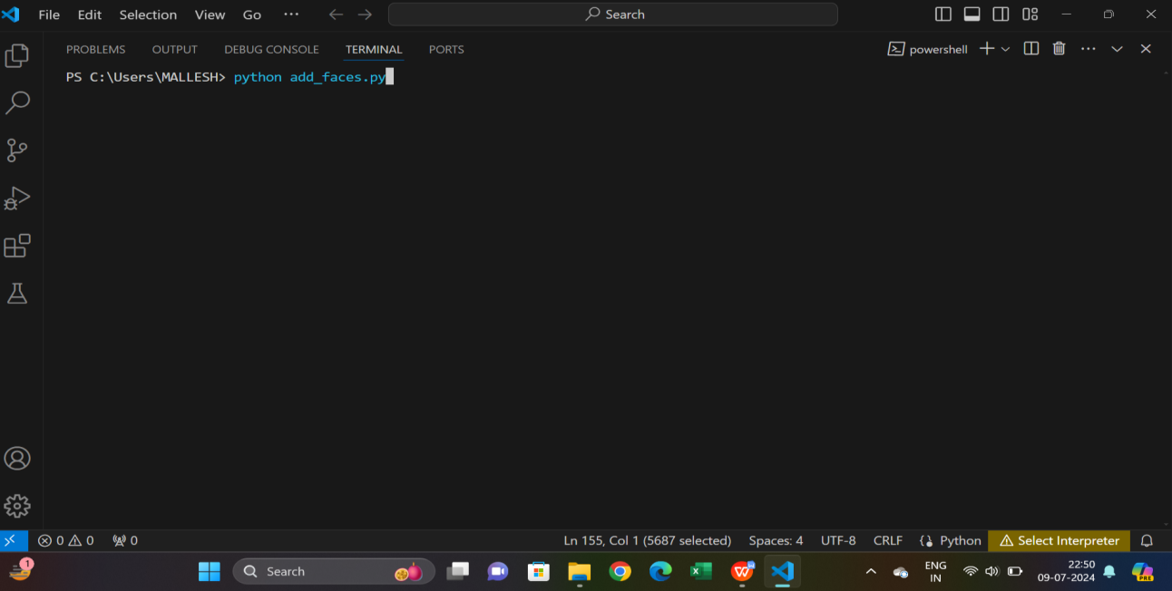

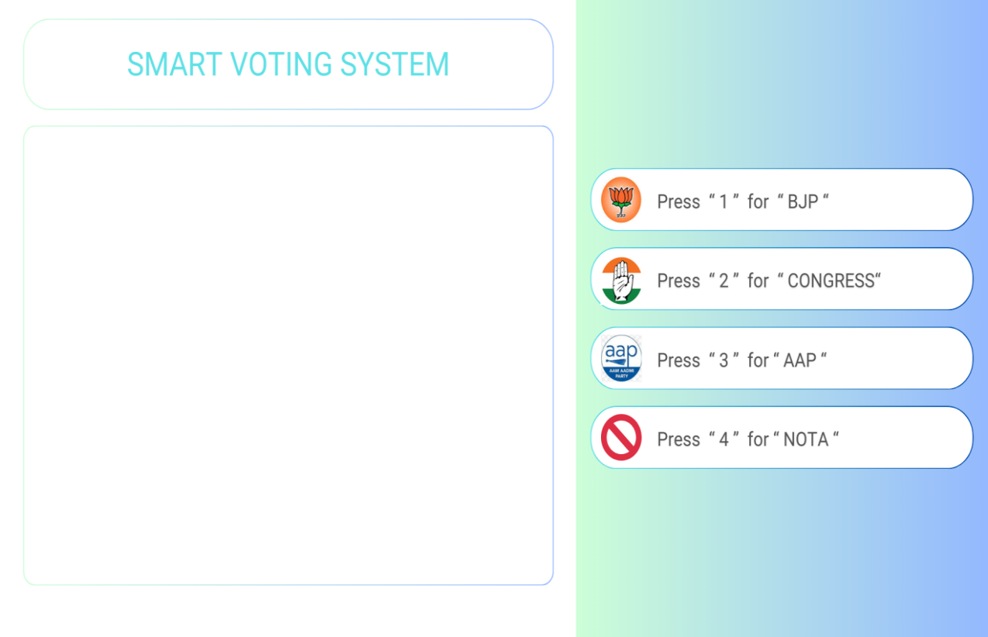

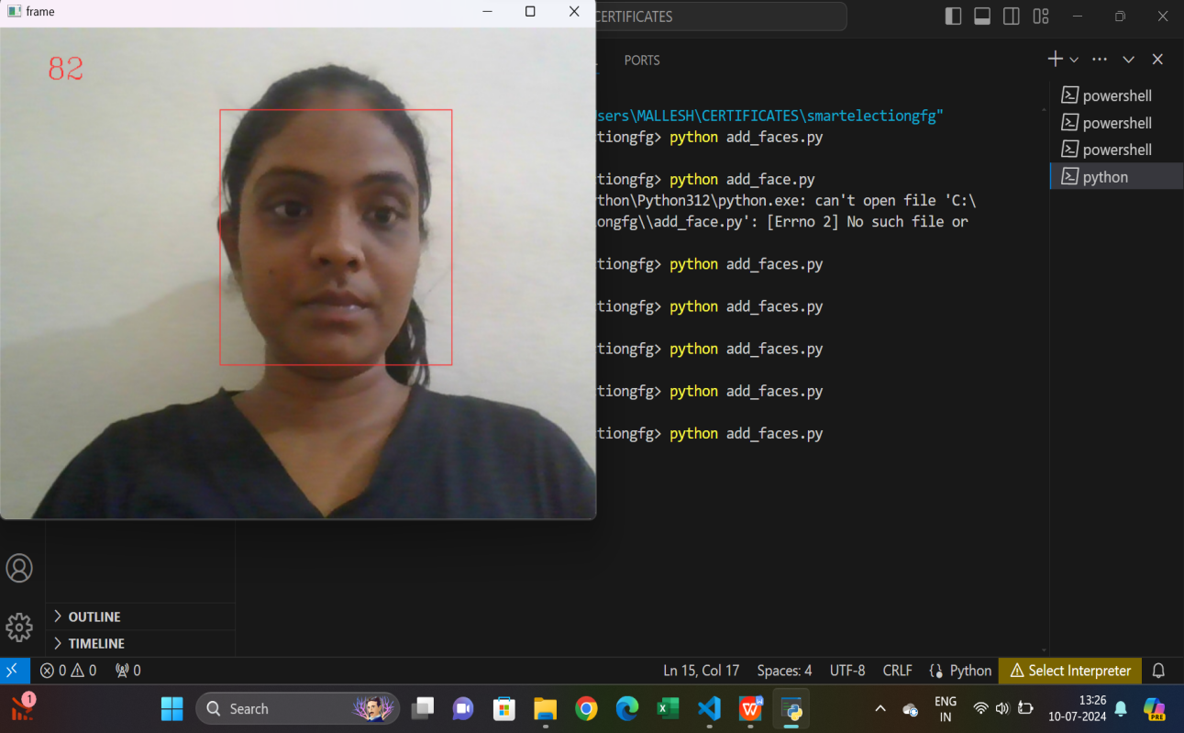

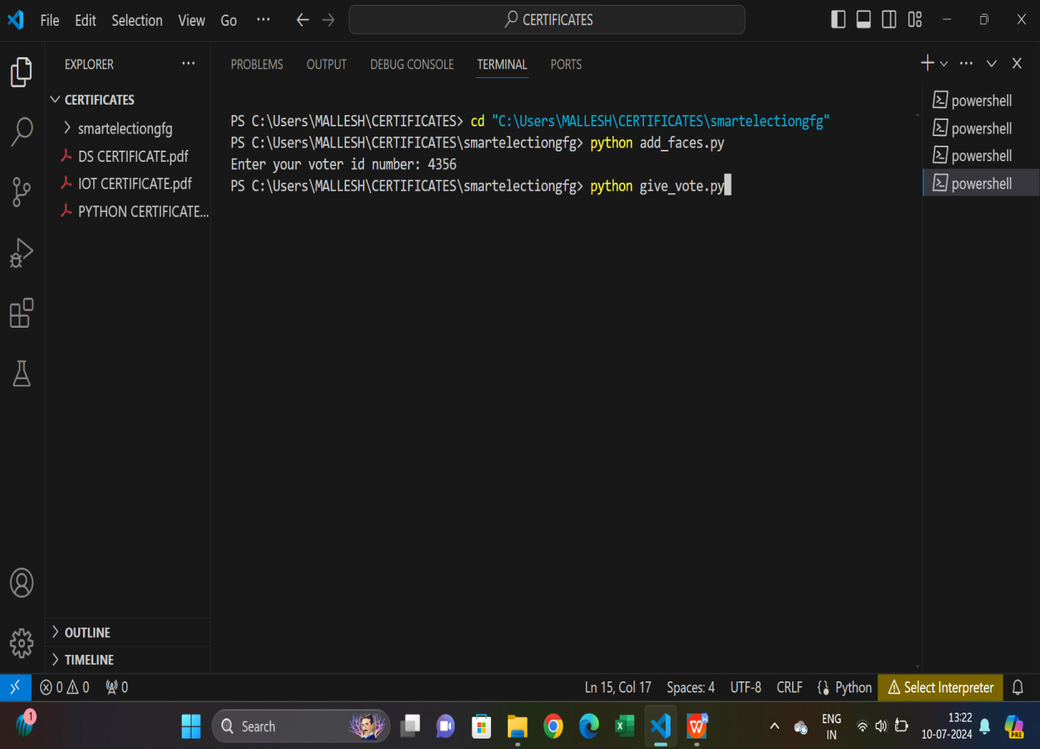

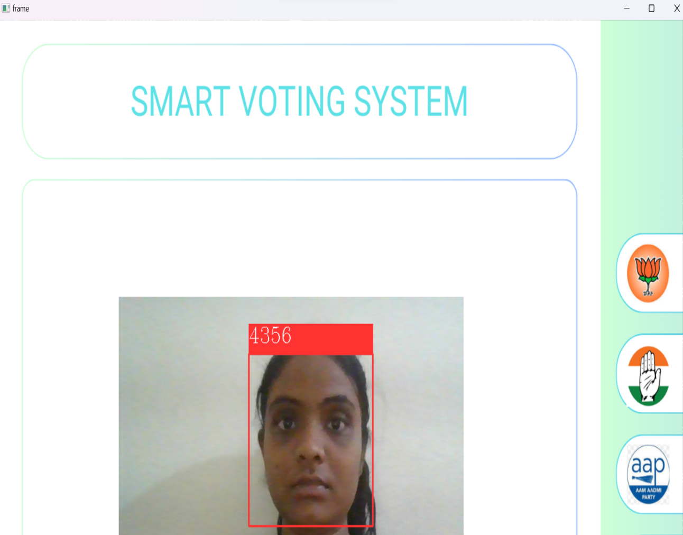

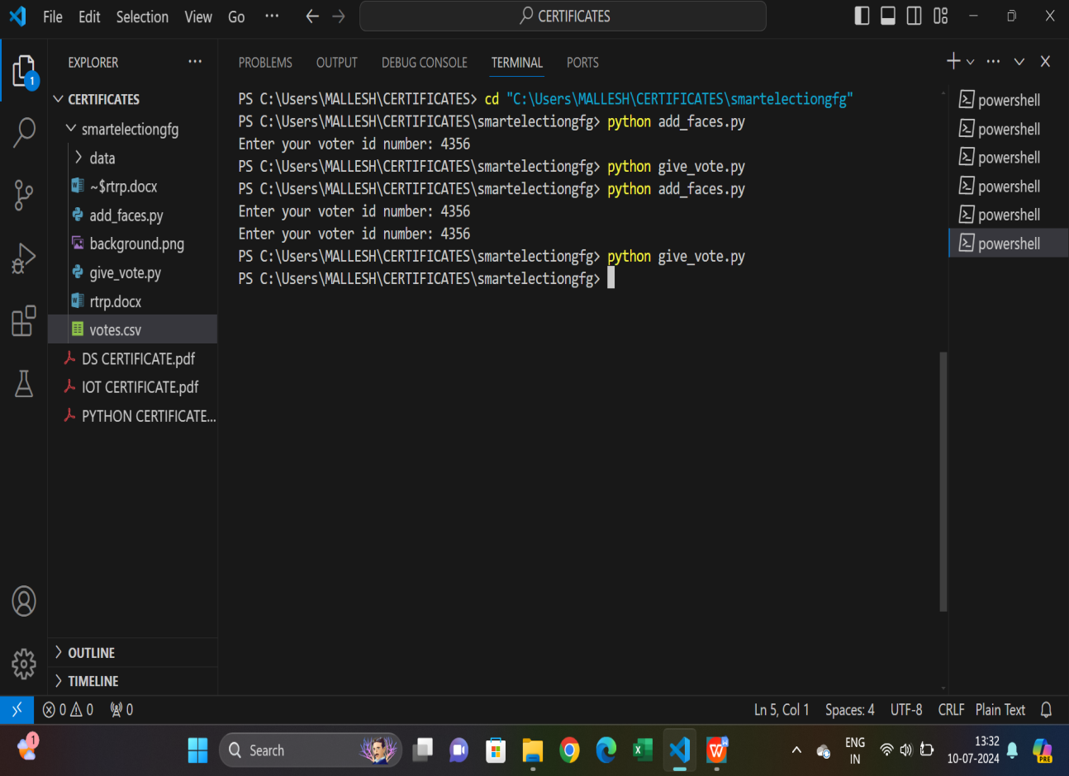

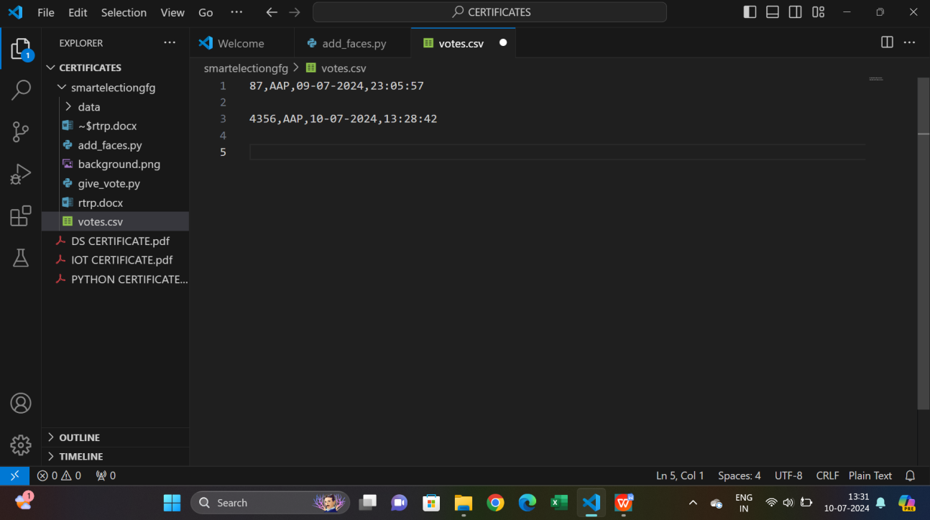

**CHAPTER 6**

**CONCLUSION AND FUTURE SCOPE**

**6.1 Conclusion**

In this project, the development of a secure online voting system that utilizes face recognition technology is proposed. To provide a secure environment for voting, OTP based access control has been implemented for the voting system's authentication. By using this proposed system, voters are able to cast their ballots in a secure setting as well as in a comfortable manner, as it is not necessary to visit a polling booth, and the issue of time and energy consumption could be eliminated. The implementation process includes the collection of datasets, image preprocessing, CNN based face recognition model training, and real time face recognition tasks in the voting system. With this implementation, an average recognition accuracy of 90% is achieved. It can be concluded that a secure voting system with CNN-based face recognition technology is able to authenticate the identity of an authorized voter, thereby preventing an unauthorized user from casting a vote. It also ensures the voter's legitimacy and the security of the voting process.

**6.2 Future Scope**

The future scope for a smart voting system utilizing face recognition technology is expansive and promising. Beyond its current applications in enhancing the security and efficiency of elections, further developments could revolutionize the electoral process. Advanced face recognition algorithms could bolster security measures, mitigating the risks of fraudulent voting and identity theft. Additionally, integrating features for accessibility, such as voice commands or gesture recognition, could ensure that voting is inclusive for all individuals, including those with disabilities. Moreover, the adoption of secure remote voting options authenticated through facial recognition could significantly increase voter turnout by offering convenience and flexibility. Furthermore, the integration of blockchain technology could create a transparent and tamper-proof voting system, safeguarding the integrity of election results. As the technology continues to evolve, there are opportunities to explore real-time monitoring of polling stations, the incorporation of additional biometric identifiers, and even international adoption to promote fair and transparent elections globally. In essence, the future of smart voting systems using face recognition holds immense potential for advancing democracy and governance worldwide.

**REFERENCES**

[1]Gupta A, Patel J, Gupta M, Gupta H., (2017), Issues and Effectiveness of

Blockchain Technology on Digital Voting. International Journal of Engineering and Manufacturing Science, Vol. 7, No. 1

[2]Navya A., Roopini R., SaiNiranjan A. S. et. Al, Electronic voting machine based on Blockchain technology and Aadhar verification, International Journal of Advance Research, Ideas and Innovations in Technology, (Volume 4, Issue 2)

[3]Hardwick, Freya Sheer, Raja NaeemAkram, and Konstantinos Markantonakis.” E-Voting with Blockchain: An E-Voting Protocol with Decentralisation and Voter Privacy.” arXiv preprint arXiv:1805.10258 (2018).

[4] Meter, Christian.” Design of Distributed Voting Systems.” arXiv preprint

arXiv:1702.02566 (2017).

[5] Panja, Somnath, and Bimal Kumar Roy. ”A secure end-to-end verifiable e- voting system using zero knowledge based blockchain.”

[6] Martin A Makary and Michael Daniel. Medical error-the third leading cause of death in the us. BMJ: British Medical Journal (Online), 353, 2016

[7] Paul Tak Shing Liu. Medical record system using blockchain, big data and tokenization. In International Conference on Information and Communications Security, pages 254–261. Springer, 2016.

[8] Christian Decker and Roger Wattenhofer. Information propagation in the bit- coin network. In Peer-to-Peer Computing (P2P), 2013 IEEE Thirteenth Inter- national Conference on, pages 1–10. IEEE, 2013.

[9] Till Neudecker, Philipp Andelfinger, and Hannes Hartenstein. Timing analysis for inferring the topology of the bitcoin peer-to-peer network. In Ubiquitous Intelligence & Computing, Advanced and Trusted Computing, Scalable Computing and Communications, Cloud and Big Data Computing, Internet people and Smart word Congress (UIC/ ATC/ ScalCom /CBDCom / loP/ SmartWorld),2016 lntl IEEE Conferences pages 358-367.IEEE,2016.

[10] Rezwan, R., Ahmed, H., Biplob, M. R. N., Shuvo, S. M., & Rahman, M. A. (2017, December). Biometrically secured electronic voting machine. In 2017 IEEE Region 10 Humanitarian Technology Conference (R10-HTC) (pp. 510-512). IEEE.

[11] Usmani, Z. A., Patanwala, K., Panigrahi, M., & Nair, A. (2017, March). Multi-purpose platformindependent online voting system. In 2017 International Conference on Innovations in Information, Embedded and Communication Systems (ICIIECS) (pp. 1-5). IEEE.

[12] N. Keerthi, A. Raghuram, and R. Jayaraman, “Interfacing of online and offline voting system with an E-voting website,” in 2022 6thInternational Conference on Devices, Circuits and Systems (ICDCS), 2022, pp. 223–228.